Canine and feline double down on dentistry
June 27-28, 2023|Oquendo Center

sponsored by:
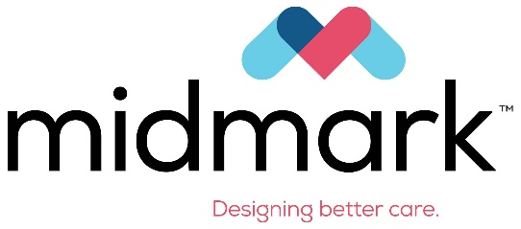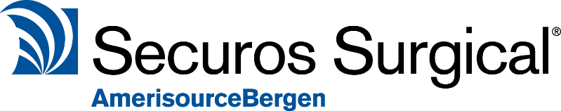

Day 1
8:00a – 12:00p | Canine Regional Anesthesia  Canine Oral Surgery – Wet Lab  Participants will learn to administer regional nerve blocks, create mucogingival flaps, and use the high-speed handpiece and appropriate burs to remove alveolar bone.  Each participant will select and use oral surgery instruments to extract the maxillary canine tooth in a canine cadaver and suture the tension-free flap to close the defect.  Complications such as flap perforation and fractured roots will be addressed as they occur.
12:00p – 1:00p | Lunch
1:00p – 5:00p | Canine Oral Surgery – Wet Lab continued  Participants will learn to section multirooted teeth effectively, use root elevators to loosen and elevate various sized tooth roots, treat complications if indicated and suture the extraction site in the canine cadaver.

Day 2
8:00a – 12:00p | Radiographic Interpretation  Feline Regional Anesthesia  Introduction to Feline Oral Surgery Wet Lab  Participants will learn to utilize and interpret dental radiographs to facilitate decision making for treatments plans.  Introduction to feline oral surgery will include the administration of regional nerve blocks. It will highlight the differences between canine and feline oral anatomy, mucogingival flap design, bone removal and surgical extractions.
12:00p – 1:00p | Lunch
1:00p – 5:00p | Feline Oral Surgery - Wet lab continued  Participants will create and execute mucogingival flaps, use the high-speed handpiece with appropriate burs to remove alveolar bone and section teeth, effectively use root elevators to loosen and elevate tooth roots and properly suture extraction site defects in feline cadavers. Complications such as fractured root retrieval will be addressed.

